ModTech International Conference - New face of TMCR
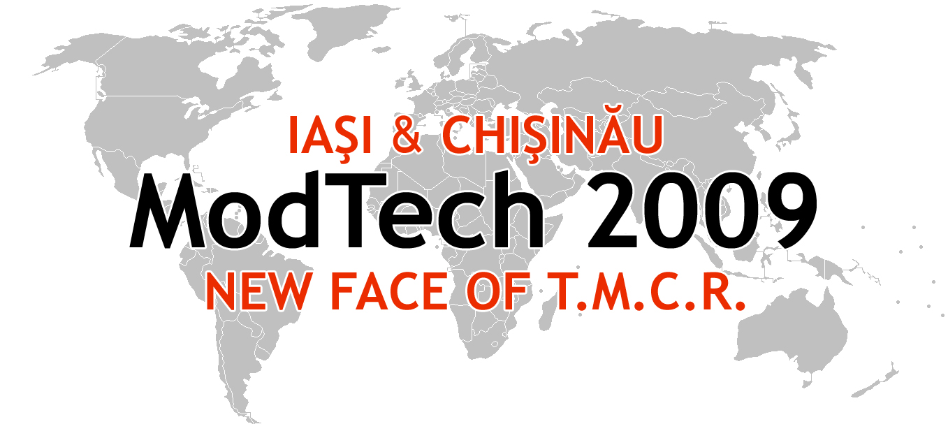

Modern Technologies, Quality and Innovation - New face of TMCR
21-23rd May
Technical Program Overview
Time\  Day | Wednesday,  May 20, 2009 | Thursday  May 21, 2009 |  |  |  |  |  |  |  | Friday  May 22, 2009 |  |  |  |  |  |  |  |  |  |  |  | Saturday  May 23, 2009
9⁰⁰-10⁰⁰ |  | Registration  to ModTech2009 |  |  |  |  |  |  |  | Section 1 – Room A-0-07  Micro and Nano Technology  Chair: Assoc.Prof. Lucian Tabacaru  Co-Chair: Assoc.Prof. Gh. Cretu | Section 2 – Room B-1-08  Manufacturing  Chair: Prof. Octavian Lupescu  Co-Chair: lecturer Ciprian Ciofu |  | Section 3 – Room A-0-08  Automation and Flexible Technologies  Chair: Prof. Petru Dusa  Co-Chair: Assoc.Prof. V. Merticaru |  | Section 4 - Room B-1-05  CAD/CAM /CAE/CAx  Work-shop: PDM/PLM  Chair: Prof. Gavril Musca  Co-Chair: Assoc.Prof. C. Carausu | Section 5 – A-2-09  Materials, processes and innovative technologies  Work-shop: New composite materials and processes  Chair: Prof. Traian Gramescu  Co-Chair: Assoc.Prof. Viorel Cohal | Section 6 – A-3-07  Project Management  Chair: Prof. Eugen Axinte  Co-Chair: Assist. M. Coteata |  | Section 7 – B-0-12  Welding and Non-Conventional Technologies  Work-shop: Development of New Non-Conventional Technologies  Chair: Assoc.Prof. Dan Ghenghea  Co-Chair: Assoc.Prof. Oana Dodun |  | Section 8 – A-3-09  Forming Technologies  Chair: Prof. Vasile Braha  Co-Chair: lecturer F. Negoescu | Closing Ceremony  Awards Ceremony  TCM 2
10⁰⁰-13⁰⁰ |  | OPENING CEREMONY, WELCOME ADDRESSES, TCM 2 Amphitheatre  Presidents of ModTech2009  Prof. Laurentiu Slatineanu, Ph. D. – Technical University „Gheorghe Asachi” of Iasi, Romania  Prof. Sergiu Mazuru, Ph. D. – Technical Univeristy of Moldova, Chisinau  Deans of Faculties:  Prof. Gheorghe Nagit, Ph.D – Dean of Faculty of Machine Manufacturing Technology and Industrial Management,  Iasi, Romania  Prof. Alexei Toca, Ph.D.- Dean of Faculty of Engineering and Management in Machine Manufacturing,  Chisinau, Republic of Moldova  PLENARY SESSION  Chairman, Prof. Dumitru Nedelcu, Ph.D.  Technical University „Gheorghe Asachi” of Iasi, Romania  -Rapid Prototyping –The Future Technologies. The parts control using video cameras  Presentation by: ing. Ioan Sescioreanu, Area Manager, BIBUS SES Timisoara, Romania  -Modern Manufacturing and Control Technologies  Presentation by: ing. Dan Popescu, General Manager INMAACRO Brasov, Romania  - Management of Technical Data into the Concept and Fabrication Aided by Computer  Presentation by: Prof. Gavril Musca, Ph.D., Technical University „Gheorghe Asachi” of Iasi, Romania  - Present and Future in Welding using Ultrasonic Technology in ISIM Timisoara  Presentation by: .dr.ing. Oanca Octavian, ISIM Timisoara, Romania  - High Fine Beating Technologies and Machines for obtaining the microns particles from normal materials and very tough materials  Presentation by: Prof. Eugen Strajescu, Ph.D., ”Politehnica” University of Bucharest, Romania
13⁰⁰-15²⁰ |  | Lunch break |  |  |  |  |  |  |  | Lunch break |  |  |  |  |  |  |  |  |  |  |  | Social Event to Cotnari Iasi
15²⁰-18²⁰ | Registration  to ModTech  2009 | Section 1 – Room A-0-07  Micro and Nano Technology  Chair: Assoc.Prof. Lucian Tabacaru  Co-Chair: lecturer Ciprian Ciofu | Section 2 – Room B-1-08  Manufacturing  Chair: Prof. Octavian Lupescu  Co-Chair: Assoc.Prof. Gh. Cretu | Section 3 – Room A-0-08  Automation and Flexible Technologies  Chair: Prof. Petru Dusa  Co-Chair: Assoc.Prof. V. Merticaru | Section 4 - Room B-1-05  CAD/CAM /CAE/CAx  Work-shop: PDM/PLM  Chair: Prof. Gavril Musca  Co-Chair: Assoc.Prof. C. Carausu | Section 5 – A-2-09  Materials, processes and innovative technologies  Work-shop: New composite materials and processes  Chair: Prof. Traian Gramescu  Co-Chair: Assoc.Prof. Viorel Cohal | Section 6 – A-3-07  Project Management  Chair: Prof. Eugen Axinte  Co-Chair: Assist. M. Coteata | Section 7 – B-0-12  Welding and Non-Conventional Technologies  Work-shop: Development of New Non-Conventional Technologies  Chair: Assoc.Prof. Dan Ghenghea  Co-Chair: Assoc.Prof. Oana Dodun | Section 8 – A-3-09  Forming Technologies  Chair: Prof. Vasile Braha  Co-Chair: lecturer F. Negoescu | Section 1 – Room A-0-07  Micro and Nano Technology  Chair: Assoc.Prof. Lucian Tabacaru  Co-Chair: Assoc.Prof. Gh. Cretu | Section 2 – Room B-1-08  Manufacturing  Chair: Prof. Octavian Lupescu  Co-Chair: lecturer Ciprian Ciofu | Section 3 – Room A-0-08  Automation and Flexible Technologies  Chair: Prof. Petru Dusa  Co-Chair: Assoc.Prof. V. Merticaru |  | Section 4 - Room B-1-05  CAD/CAM /CAE/CAx  Work-shop: PDM/PLM  Chair: Prof. Gavril Musca  Co-Chair: Assoc.Prof. C. Carausu |  | Section 5 – A-2-09  Materials, processes and innovative technologies  Work-shop: New composite materials and processes  Chair: Prof. Traian Gramescu  Co-Chair: Assoc.Prof. Viorel Cohal | Section 6 – A-3-07  Project Management  Chair: Prof. Eugen Axinte  Co-Chair: Assist. M. Coteata | Section 7 – B-0-12  Welding and Non-Conventional Technologies  Work-shop: Development of New Non-Conventional Technologies  Chair: Assoc.Prof. Dan Ghenghea  Co-Chair: Assoc.Prof. Oana Dodun |  | Section 8 – A-3-09  Forming Technologies  Chair: Prof. Vasile Braha  Co-Chair: lecturer F. Negoescu |  | Social Event to Cotnari Iasi
18⁴⁵-22³⁰ |  | Gala Dinner – Motel Bucium |  |  |  |  |  |  |  |  |  |  |  |  |  |  |  |  |  |  |  | Social Event to Cotnari Iasi
Place of the Conference:
Department of Machine Manufacturing Technology, Faculty of Machine Manufacturing and Industrial Management, Technical University „Gheorghe Asachi” of Iasi, Romania,
Bd. Mangeron nr. 59A, 700050, Iasi, Romania
Room A-0-07: Laboratory of Fine Mechanics and Nano Technologies,
Room B-1-08: Laboratory of Computer Aided Design - 1
Room A-0-08: Laboratory of Flexible Manufacturing Technologies
Room B-1-05: Laboratory of Computer Aided Design -2
Room A-2-09: Laboratory of Automation and Robotics in Technology
Room A-3-07: Laboratory of Project Management
Room B-0-12: Laboratory of Non-Conventional Technologies
Room A-3-09: Laboratory of Experimental Researching

